Organic Chemistry 12BL Spring 2020

Tues/Thurs Schedule

*Please note: lecture and lab are two separate courses – schedules will not necessarily correspond identically.

Week of…. Tuesday Thursday

1/6 Check-in In-class Packet

1/13 1) Diels Alder 1) Diels Alder

1/20 2) Extraction & 2) Extraction &
Saponification Saponification

1/27 3) Salicylic Acid 3) Salicylic Acid
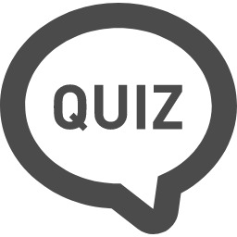
Synthesis Synthesis
Quiz (Expts 1 & 2)

2/3 4) Aspirin Synthesis 4) Aspirin Synthesis

2/10 5) Vanillin Reduction 5) Vanillin Reduction
Quiz (Expts 3 & 4)

2/17 6) NMR Analysis 6) NMR Analysis

2/24 7) Directive Effects in 7) Directive Effects in
the Bromination of the Bromination of
Vanillin Vanillin
Quiz (Expts 5 & 6)

Week of… Tuesday Thursday

3/2 8) Friedel Crafts 8) Friedel Crafts
Acylation Acylation

3/9 9) Aldol Condensation- 9) Aldol Condensation-
Dehydration Dehydration
Quiz (Expts 7 & 8)

3/16 9) Aldol-Condensation- NO SCHOOL Dehydration

3/23 10) Diazo Dyes 10) Diazo Dyes

3/30 10) Diazo Dyes 11) Multi-Step
(Mandatory tie-dye) Synthesis

4/6 Spring Break Spring Break

4/13 11) Multi-Step 11) Multi-Step
Synthesis Synthesis
Quiz (Expts 9 & 10)

4/20 11) Multi-Step 11) Multi-Step
Synthesis Synthesis

4/27 11) Multi-Step Lab Practical
Synthesis
Quiz (Expt 11)

5/4 Lab Practical

Important Dates to Remember:
Last day to drop without a W 1/24
Last day to drop with a W 4/17

